**How to Use the QR Ticket Booking System:**

1. **Registration and Login:**
   * A computer screen with a qr code

     Description automatically generatedAccess the system through the provided platform or application.
   * A computer screen shot of a black box

     Description automatically generatedIf you're a new user, you'll need to register by providing necessary details like name, email, and password.
   * A screenshot of a computer

     Description automatically generatedOnce registered, log in using your credentials.
2. **Navigating the System:**
   * A screenshot of a computer

     Description automatically generatedUpon logging in, you'll land on the home/dashboard page of the system.
   * A screenshot of a computer

     Description automatically generatedHere, you'll find options to perform various tasks related to ticket booking and management.
3. **Viewing Concert Details:**

* A screenshot of a computer

  Description automatically generatedTo view details about a concert, navigate to the "Concerts" or similar section on the dashboard.
* Browse through the list of available concerts or use the search feature to find a specific concert.

* Click on the concert title or image to view more details such as venue, date, time, performers, and any additional information provided by the organizer. Then can click “Book Ticket” or “Book Through WhatsApp” to perform booking process.

1. **Booking Tickets:**
   * A computer screen shot of a computer screen

     Description automatically generatedTo book tickets for an event, locate the "Book Tickets" or similar option on the dashboard.
   * Select the event you wish to book tickets for. This may involve choosing from a list of available events or searching for a specific event.
   * Follow the prompts to select the number of tickets, seat preferences (if applicable), and other relevant details.
   * A screenshot of a computer

     Description automatically generatedAfter confirming your selection, select “Book ticket” complete the booking process.
2. **Generating QR Code Tickets:**
   * 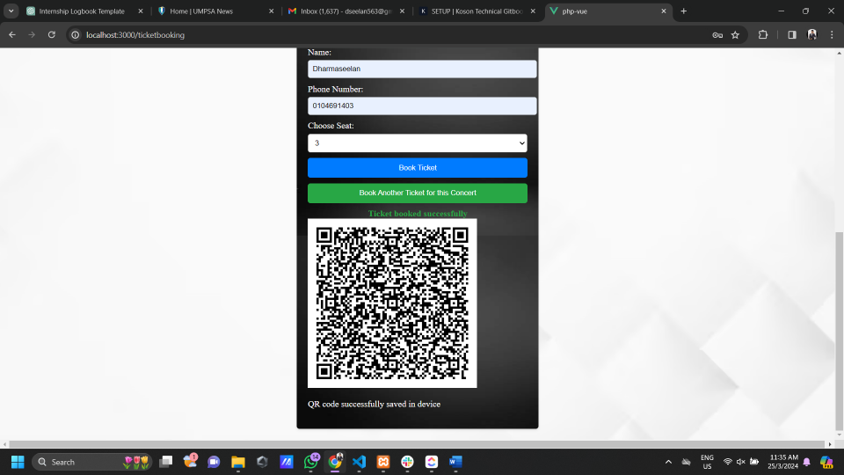Once the booking is confirmed is processed, the system will generate QR code tickets for the booked event.
   * You can access your QR code tickets either immediately after booking or through a designated section within the system.
3. **Accessing QR Code Tickets:**
   * Navigate to the section labelled "Profile".
   * A screenshot of a computer

     Description automatically generatedHere, you'll find a list of all the tickets you've booked.
4. **Cancelling Booking:**
   * If you need to cancel a booking, navigate to the "Profile".
   * A screenshot of a computer

     Description automatically generatedLocate the booking you wish to cancel and follow the provided instructions to cancel it.
   * Note any cancellation fees or policies that may apply.
5. **Using QR Code Tickets:**
   * On the day of the event, ensure you have your QR code ticket accessible through the system.
   * When prompted at the event venue, present your QR code ticket for scanning.
   * The event staff will scan your QR code to validate your ticket and grant you entry to the event.
6. **Viewing Tickets via QR Code:**

* **Camera Scanning:**
  + Access the "Scan QR Code" feature within the system.
  + Use the device's camera to scan the QR code displayed on the ticket.
  + Upon successful scanning, the system will authenticate the ticket and display relevant ticket details to the user.
* **File Upload:**
  + Navigate to the "Upload QR Code" section or similar within the system.
  + Choose the option to upload a QR code file from your device.
  + Select the QR code image file containing the ticket information.
  + After uploading, the system will process the QR code file and extract the ticket details for display.
* **QR Machine:**
  + Locate a designated QR machine at the event venue or any other accessible location.
  + Follow the instructions provided by the QR machine to scan the QR code on the ticket.
  + Once scanned, the machine will authenticate the ticket and display the relevant ticket details on its screen for verification.

1. **Support and Assistance:**
   * If you encounter any issues or have questions about using the system, refer to the provided help documentation or contact customer support for assistance.
   * Utilize any FAQs, guides, or tutorials available within the system to enhance your understanding of its features and functionalities.
2. **Feedback and Improvement:**
   * After using the system, consider providing feedback on your experience. This can help the system administrators improve and enhance the platform for future users.